Design document: FoodBridge
By: Simeon Markov
Institution Name: Fontys UAS
Course/Class: ICT/EN08
Date: 2025-12-11

Introduction
The purpose of this document is to set a clear design plan, illustrating incorporated layout principles. It includes the wireframing process, explaining each wireframe and the user flow as well as the design of the database (shown in EER diagram) explaining fields and relations between tables.

Design Guide (UI/UX Principles)
This section presents the initial design plan (incorporating layout principles, accessibility, etc.)
User-Centric: Interfaces should align with the organizational needs and expectations (key features).
Visual Hierarchy: Having a strategic application of layout, color, typography, and spacing to emphasize high-priority data while minimizing cognitive load.
Simplicity and clarity: Presenting complex information in digestible formats without overwhelming users with excessive visual elements (for example adhering to the 5-second rule).
Consistency: Consistency across typography, color schemes, button styles, and interactive behaviors.
Appropriate Visualization Selection: Matching chart types to data characteristics and analytical objectives. Line charts excel at temporal trend representation, bar charts facilitate categorical comparisons.
Real-Time Data Presentation and Contextual Feedback: Dashboards should provide real-time data visualization in formats that remain clear yet unobtrusive. Users require constant awareness of system status through loading indicators, success and error messages, and visual cues guiding interactions.
Big As Numbers (BANs): Providing context through comparisons, trend lines, or sparklines rather than isolated numerical values.

Wireframing
The wireframing was done on Figma: Popular software for designing and prototyping.

Login system
The login system is the entry-point of the foodbank app. The user is navigated to the login/registration page for authentication and afterwards he/she could access the dashboard.
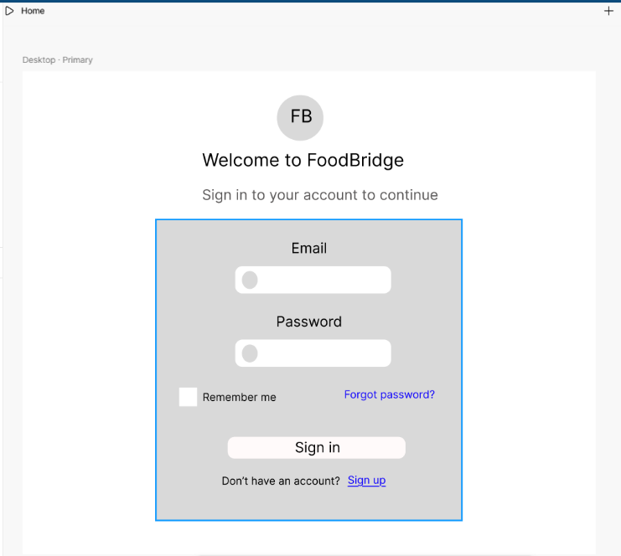
Figure

1

:

Login page

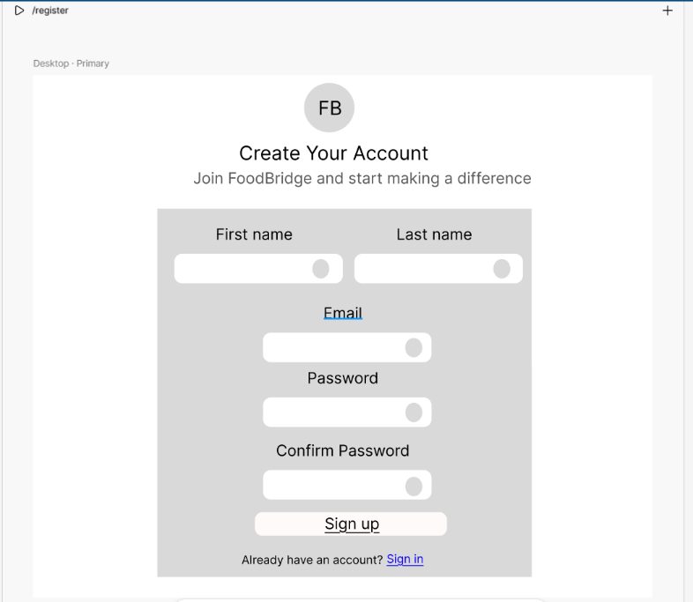
Figure 2: Register page

Index page
This page contains dashboard content (managing donors, food supplies, etc.). It is the first page the authenticated user is going to see when logged in.
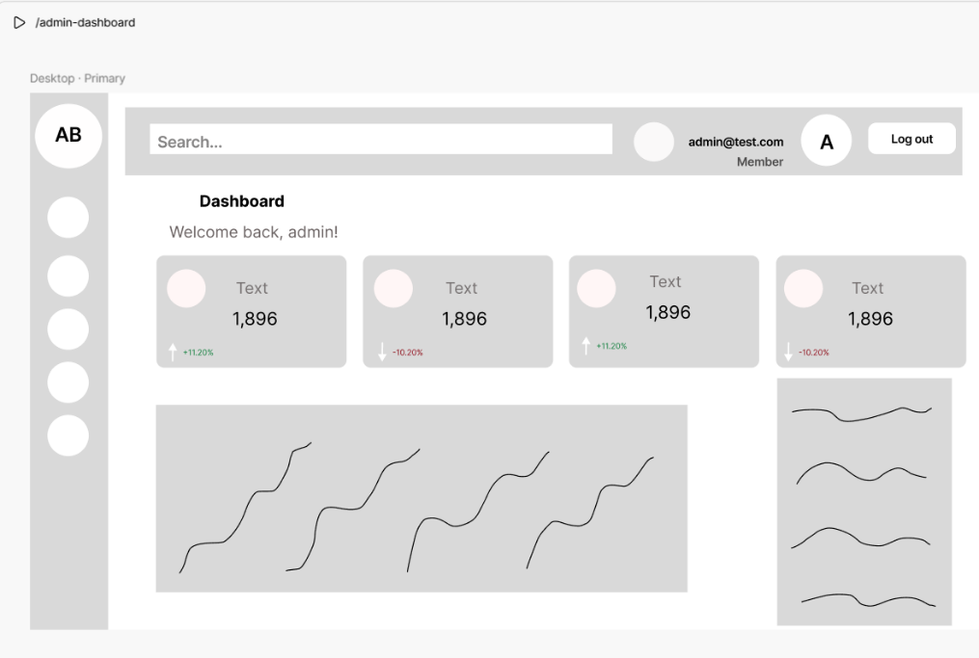
Figure 3: Dashboard page
Breakdown: The page consists of several containers: nav (containing all the links to the different internal pages within the dashboard), search (global search) and main container, which contains data analytics (e.g. charts).

Manage Resource page
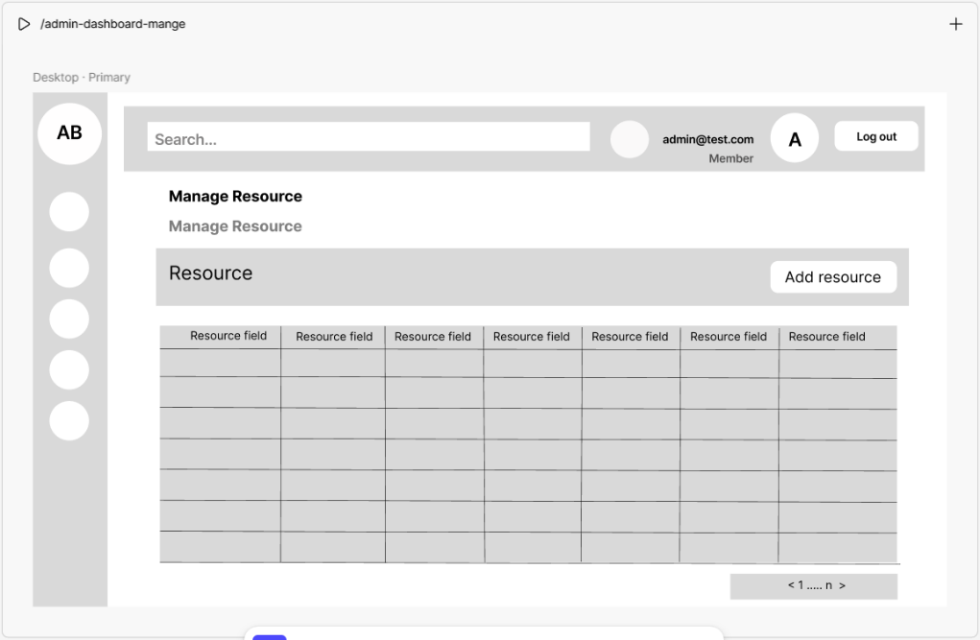
Figure 4: Manage resource page
Breakdown: The page consists of dynamic components for the different sections of the management resources page. It displays the resource that is to be manipulated (create, update, delete) and a table showing the records for each resource fetched from the database. On the bottom right is positioned the pagination.

Profile component
Contains personal information.
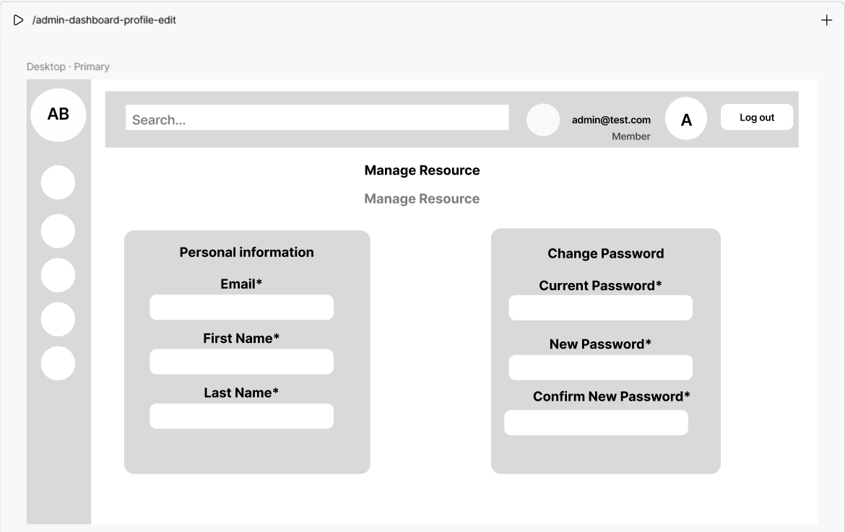
Figure 5:Profile page
Breakdown: Users can change their personal information by updating the related fields.

Techstack decision

Frontend Architecture
- React 18 delivers substantial performance improvements through concurrent rendering, which enables the framework to pause, resume, and prioritize rendering work (UI remains responsive even during complex operations).
- JavaScript: The standard language for web development, ensuring broad compatibility and a vast ecosystem of libraries and tools.
- Tailwind CSS: Its utility-first approach eliminates the bloat of unused styles. Tailwind's JIT (Just-in-Time) mode generates styles on-demand during development while ensuring production builds contain only the classes used in the codebase.
- Recharts: integrates seamlessly with React's component model, following declarative patterns familiar to React developers. Built on D3.js submodules, it provides a composable, lightweight charting solution with native SVG support.

Backend Architecture
- C#: offers type safety, mature tooling, and exceptional performance for backend operations.
- ASP.NET Core 8: Delivers exceptional performance. Enhanced features like improved form binding in Minimal APIs, better Blazor support, and dynamic Profile-Guided Optimization (PGO) enabled by default deliver approximately 15% average performance improvements.
- SQL Server provides enterprise-grade reliability with features specifically designed for complex workloads. In-Memory OLTP and Columnstore Indexes enhance transaction processing and query performance, enabling faster data access and real-time analytics. The database integrates seamlessly with the Microsoft ecosystem—including SSMS, Azure, Power BI.

Database design
(SSMS) SQL Server Management Studio (RDBMS) was used for generating the EER diagram. The diagram was generated based on the migrations (code-first approach).

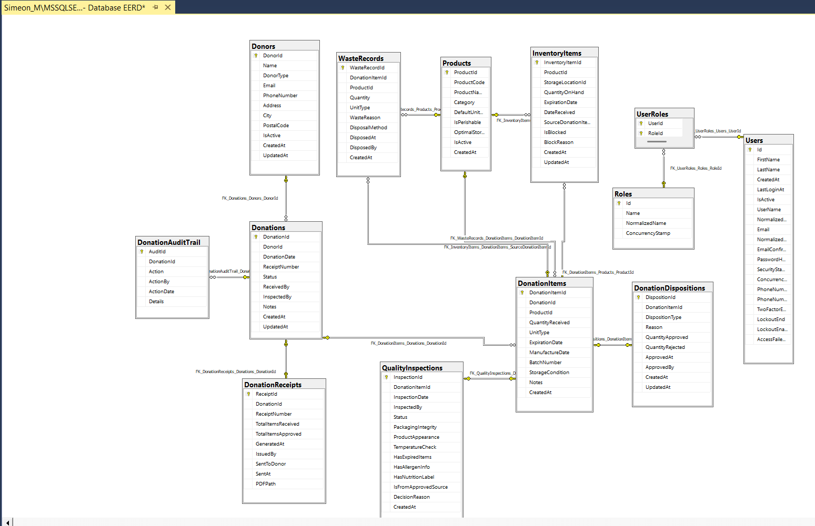
Figure 9: Database diagram

Overview
List of all entities:
- Donation
- DonationAuditTrail
- DonationDisposition
- DonationItem
- DonationReceipt
- Donor
- InventoryItem
- Products
- QualityInspection
- WasteRecord

Core Entities:
- Users: This table stores user information, including their name, email, password.
- Donors: This table the credentials of the donors like name, email, etc.
- Donations: This table defines the donation’s status, donated date, inspected by, etc. It establishes a many-to-one relationship with the Donors table (one donor could make multiple donations).
- Products: This table stores product’s data like name, category, quantity, etc.
- InventoryItems: This is the table for keeping track of storing the products (storage location, which is foreign key, expiration date). The established relationship between table Products is many-to-one (many products could belong to one storage).
- Key Relationships:
- One donor could make multiple donations (one-to-many).
- Products could have one storage location (many-to-one).
- A product of donation could pass several inspections (many-to-one).

Tables description

‘DonationAuditTrail:

Column | Type | Constraint | Description
AuditId | INT | PRIMARY KEY, AUTO_INCREMENT | Unique record id
DonationId | INT | NOT NULL, FOREIGN KEY | Links to Donations table
Action | NVARCHAR(100) | NOT NULL | Type of action (edit, approve, etc.)
ActionBy | INT | NOT NULL | User who performed the action
ActionDate | DATETIME | NOT NULL | When the action occurred
Details | LONGTEXT | NOT NULL | Details of the activity
Table 1: DonationAuditTrail

‘DonationDispositions:

Column | Type | Constraint | Description
DispositionId | INT | PRIMARY KEY, AUTO_INCREMENT | Unique disposition record id
DonationItemId | INT | NOT NULL, FOREIGN KEY | Links to DonationItems table
DispositionType | NVARCHAR(50) | NOT NULL | Approval/rejection type (approved/rejected)
Reason | LONGTEXT | NOT NULL | Reason for approval or rejection
QuantityApproved | INT | NULL | Approved quantity
QuantityRejected | INT | NULL | Rejected quantity
ApprovedAt | DATETIME | NULL | Approval time
ApprovedBy | INT | NULL | User who approved
CreatedAt | DATETIME | NOT NULL | Record creation time
UpdatedAt | DATETIME | NOT NULL | Last update time
Table 2: DonationDispositions
‘DonationItems:

Column | Type | Constraint | Description
DonationItemId | INT | PRIMARY KEY, AUTO_INCREMENT | Unique item id
DonationId | INT | NOT NULL, FOREIGN KEY | Links to Donations table
ProductId | INT | NOT NULL, FOREIGN KEY | Links to Products catalog
QuantityReceived | INT | NOT NULL | Received quantity
UnitType | NVARCHAR(50) | NOT NULL | Unit of measurement
ExpirationDate | DATETIME | NULL | Expiry date if applicable
ManufactureDate | DATETIME | NULL | Date made
BatchNumber | NVARCHAR(100) | NOT NULL | Batch identification number
StorageCondition | NVARCHAR(100) | NOT NULL | Required storage conditions
Notes | LONGTEXT | NULL | Additional remarks
CreatedAt | DATETIME | NOT NULL | Record creation time
Table 3: DonationItems

‘DonationReceipts:

Column | Type | Constraint | Description
ReceiptId | INT | PRIMARY KEY, AUTO_INCREMENT | Unique receipt id
DonationId | INT | NOT NULL, FOREIGN KEY | Links to Donations table
ReceiptNumber | NVARCHAR(50) | NOT NULL, UNIQUE | Unique receipt code
TotalItemsReceived | INT | NOT NULL | Number of items received
TotalItemsApproved | INT | NOT NULL | Number of items approved
GeneratedAt | DATETIME | NOT NULL | Date receipt was generated
IssuedBy | INT | NOT NULL | User who created the receipt
SentToDonor | BOOLEAN | NOT NULL, DEFAULT FALSE | Whether sent to donor
SentAt | DATETIME | NULL | When sent to donor
PDFPath | NVARCHAR(500) | NOT NULL | File path for receipt PDF
Table 4: DonationReceipts.
‘Donations’:

Column | Type | Constraint | Description
DonationId | INT | PRIMARY KEY, AUTO_INCREMENT | Unique donation id
DonorId | INT | NOT NULL, FOREIGN KEY | Links to Donors table
DonationDate | DATETIME | NOT NULL | Date received
ReceiptNumber | NVARCHAR(50) | NOT NULL, UNIQUE | Receipt code
Status | NVARCHAR(50) | NOT NULL | Current status of donation
ReceivedBy | INT | NOT NULL | User who accepted donation
InspectedBy | INT | NULL | User who inspected (if any)
Notes | LONGTEXT | NOT NULL | Remarks
CreatedAt | DATETIME | NOT NULL | Record created
UpdatedAt | DATETIME | NOT NULL | Last modification
Table 5: Donations

‘Donors’:

Column | Type | Constraint | Description
DonorId | INT | PRIMARY KEY, AUTO_INCREMENT | Unique donor id
Name | NVARCHAR(255) | NOT NULL | Donor organization/person name
DonorType | NVARCHAR(50) | NOT NULL | Type (individual, company, etc.)
Email | NVARCHAR(255) | NOT NULL, UNIQUE | Email contact
PhoneNumber | NVARCHAR(20) | NOT NULL | Phone
Address | NVARCHAR(500) | NOT NULL | Full address
City | NVARCHAR(100) | NOT NULL | City
PostalCode | NVARCHAR(10) | NOT NULL | Postal/Zip code
IsActive | BOOLEAN | NOT NULL, DEFAULT TRUE | Donor account enabled or not
CreatedAt | DATETIME | NOT NULL | When created
UpdatedAt | DATETIME | NOT NULL | Last update
Table 6: Donors’

‘InventoryItems’:

Column | Type | Constraint | Description
InventoryItemId | INT | PRIMARY KEY, AUTO_INCREMENT | Inventory item id
ProductId | INT | NOT NULL, FOREIGN KEY | Product catalog reference
StorageLocationId | INT | NULL | Storage location (if tracked)
QuantityOnHand | INT | NOT NULL | Stock quantity available
ExpirationDate | DATETIME | NULL | Best before date
DateReceived | DATETIME | NOT NULL | Date received
SourceDonationItemId | INT | NULL, FOREIGN KEY | Links to original donation item
IsBlocked | BOOLEAN | NOT NULL, DEFAULT FALSE | Flag if inventory blocked
BlockReason | LONGTEXT | NOT NULL | Reason for blocking (required)
CreatedAt | DATETIME | NOT NULL | Record creation time
UpdatedAt | DATETIME | NOT NULL | Last update
Table 7: InventoryItems’

‘Products’:

Column | Type | Constraint | Description
ProductId | INT | PRIMARY KEY, AUTO_INCREMENT | Unique catalog id
ProductCode | NVARCHAR(50) | NOT NULL, UNIQUE | SKU/product code
ProductName | NVARCHAR(255) | NOT NULL | Product name
Category | NVARCHAR(100) | NOT NULL | Product category
DefaultUnitType | NVARCHAR(50) | NOT NULL | Default unit type
IsPerishable | BOOLEAN | NOT NULL | If product can expire
OptimalStorageCondition | NVARCHAR(100) | NOT NULL | Best storage condition
IsActive | BOOLEAN | NOT NULL, DEFAULT TRUE | Product enabled for transactions
CreatedAt | DATETIME | NOT NULL | When product was added

Table 8: Products

‘QualityInspections’:

Column | Type | Constraint | Description
InspectionId | INT | PRIMARY KEY, AUTO_INCREMENT | Quality inspection record id
DonationItemId | INT | NOT NULL, FOREIGN KEY | Links to DonationItems
InspectionDate | DATETIME | NOT NULL | Date of inspection
InspectedBy | INT | NOT NULL | User who inspected
Status | NVARCHAR(50) | NOT NULL | Status (passed, failed, etc.)
PackagingIntegrity | NVARCHAR(50) | NOT NULL | Packaging quality
ProductAppearance | NVARCHAR(50) | NOT NULL | Appearance assessment
TemperatureCheck | DECIMAL(18,2) | NULL | Temperature (if tracked)
HasExpiredItems | BOOLEAN | NOT NULL | Expiry indicator
HasAllergenInfo | BOOLEAN | NOT NULL | Allergen info check
HasNutritionLabel | BOOLEAN | NOT NULL | Nutrition label present
IsFromApprovedSource | BOOLEAN | NOT NULL | Source validity check
DecisionReason | LONGTEXT | NULL | Inspector's rationale
CreatedAt | DATETIME | NOT NULL | Creation time
Table 9: QualityInspections

‘Roles’:
Column | Type | Constraint | Description
Id | NVARCHAR(450) | PRIMARY KEY | Role id
Name | NVARCHAR(256) | NULL | Role name (friendly)
NormalizedName | NVARCHAR(256) | NULL | Normalized name (standard comparison)
ConcurrencyStamp | LONGTEXT | NULL | Stamp for concurrency check
Table 10: Roles

‘UserRoles’:
Column | Type | Description | Constraints
id | VARCHAR(255) | Primary key, unique identifier for the job batch. | Primary  Key
name | VARCHAR(255) | A descriptive name for the job batch. | Not Null
total_jobs | INT | The total number of jobs in the batch. | Not Null
pending_jobs | INT | The number of jobs in the batch that are still pending. | Not Null
failed_jobs | INT | The number of jobs in the batch that have failed. | Not Null
failed_job_ids | LONGTEXT | A serialized list of IDs of the failed jobs within the batch. | Not Null
options | MEDIUMTEXT | Configuration options for the job batch. | Nullable
cancelled_at | INT | Unix timestamp indicating when the job batch was cancelled. | Nullable
created_at | INT | Unix timestamp indicating when the job batch was created. | Not Null
finished_at | INT | Unix timestamp indicating when the job batch was completed. | Nullable
Table 11: UserRoles (pivot table)

‘Users’:

Column | Type | Constraint | Description
Id | NVARCHAR(450) | PRIMARY KEY | User id
FirstName | LONGTEXT | NULL | First name
LastName | LONGTEXT | NULL | Last name
CreatedAt | DATETIME | NOT NULL | Creation date
LastLoginAt | DATETIME | NULL | Last login
IsActive | BOOLEAN | NOT NULL, DEFAULT TRUE | User enabled/disabled
UserName | NVARCHAR(256) | NULL | Username
NormalizedUserName | NVARCHAR(256) | NULL | Normalized name for login
Email | NVARCHAR(256) | NULL | Email address
NormalizedEmail | NVARCHAR(256) | NULL | Normalized email for search/login
EmailConfirmed | BOOLEAN | NOT NULL | Email verification status
PasswordHash | LONGTEXT | NULL | Encrypted password
SecurityStamp | LONGTEXT | NULL | Security reset stamp
ConcurrencyStamp | LONGTEXT | NULL | Stamp for concurrency checks
PhoneNumber | LONGTEXT | NULL | User phone number
PhoneNumberConfirmed | BOOLEAN | NOT NULL | Phone number verification status
TwoFactorEnabled | BOOLEAN | NOT NULL | Whether 2FA is active
LockoutEnd | DATETIME | NULL | Account lockout end date
LockoutEnabled | BOOLEAN | NOT NULL | Whether account can be locked
AccessFailedCount | INT | NOT NULL | Failed login attempts
Table 12: Users

‘WasteRecords’:
Column | Type | Description | Constraints
id | BIGINT | Primary key, unique identifier for the attachment. | Primary Key
post_id | BIGINT | Foreign key, references the ID of the post the attachment belongs to. | Foreign Key  (posts.id)
name | VARCHAR(255) | The original name of the attached file. | Not Null
file_path | VARCHAR(255) | The path where the attached file is stored. | Not Null
mime_type | VARCHAR(20) | The MIME type of the attached file (e.g., 'image/jpeg', 'video/mp4'). | Not Null
created_by | BIGINT | Foreign key, references the ID of the user who uploaded the attachment. | Foreign Key  (users.id)
created_at | TIMESTAMP | Timestamp indicating when the attachment was created. | Not Null
Table 13: WasteRecords’

References
- Vishwark. (2025). React 18 Features You Must Understand in 2025 (Deep Explanation + Real Insights). https://dev.to/vishwark/react-18-features-you-must-understand-in-2025-deep-explanation-real-insights-8e1
- Kacper, Rafalski (2025). The Future of React: Top Trends Shaping Frontend Development in 2025. https://www.netguru.com/blog/react-js-trends
- Why is Tailwind CSS better than other CSS framework. https://windframe.dev/blog/why-tailwind-css-is-good
- TailwindCSS Documentation. https://v3.tailwindcss.com/docs/optimizing-for-production
- Paul, Bratslavsky (2025). Top 5 Chart Libraries to use in Your Next Project. https://strapi.io/blog/chart-libraries
- Richa (2025). .NET 8: A Comprehensive Overview and New Features. https://eluminoustechnologies.com/blog/net-8-features/
- Nisarg, Rami (2025). Benefits of Using React with ASP .Net Core.
https://www.c-metric.com/blog/using-react-with-asp-net-core/
- Stephen, Planck (2025). Why SQL Server Provides Value for the Enterprise: A Comparative Look at PostgreSQL.
https://www.sqltabletalk.com/?p=722

